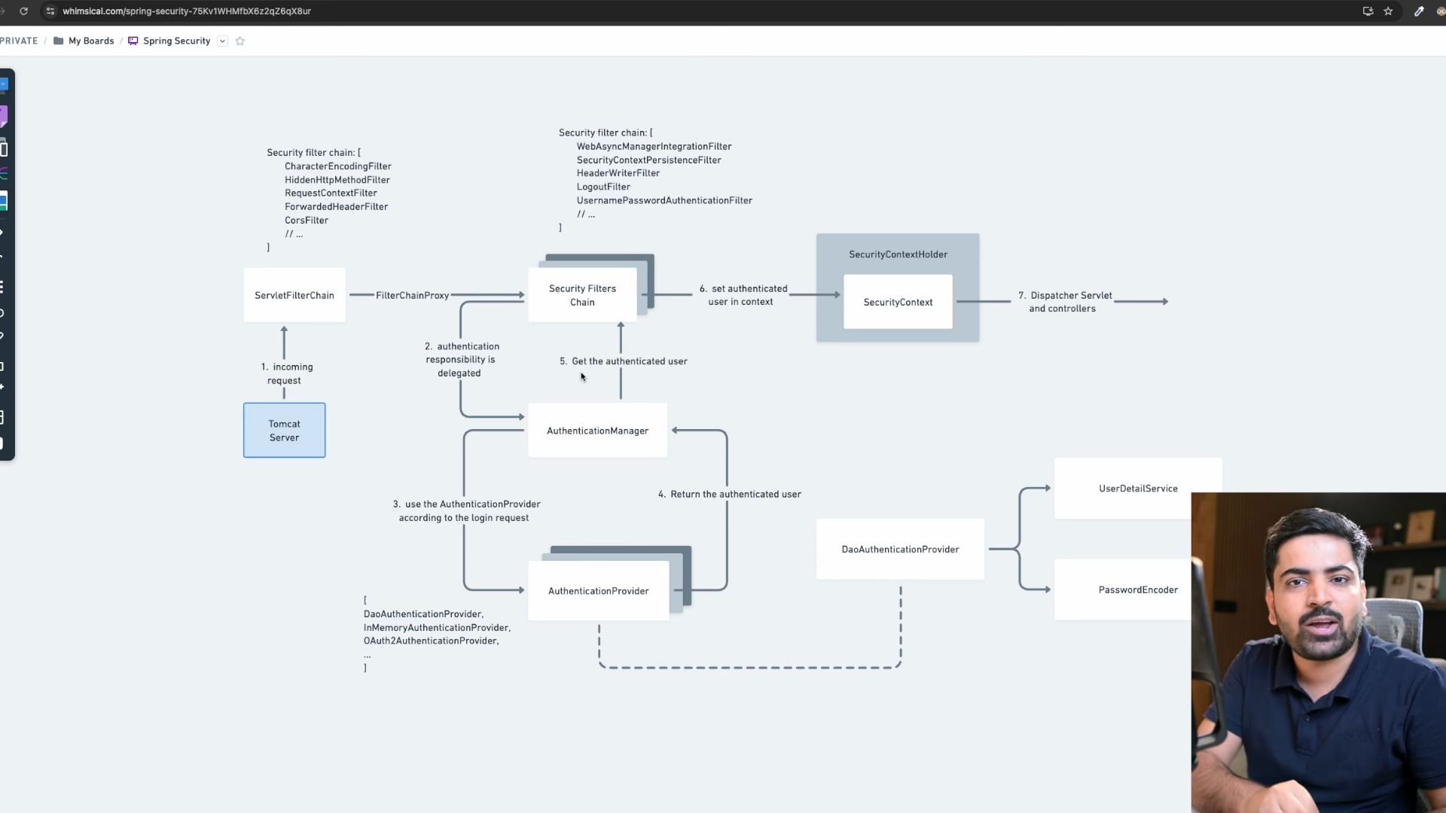
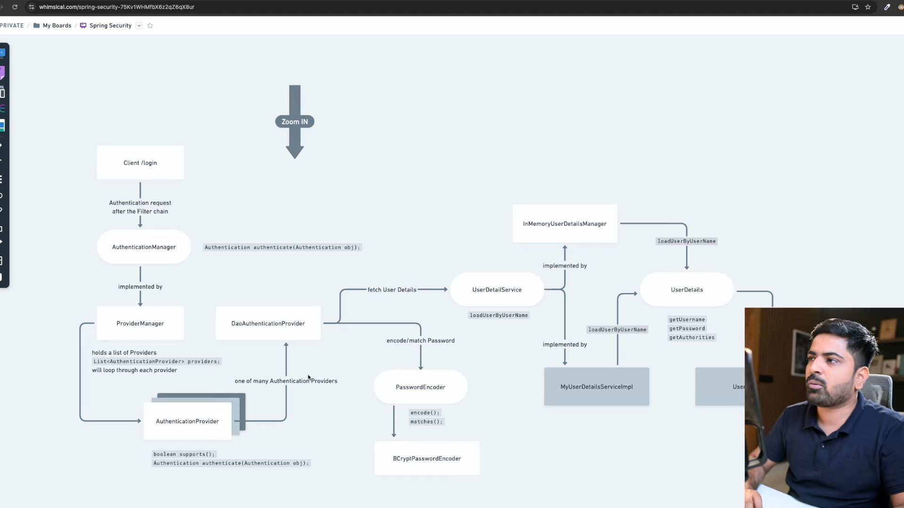
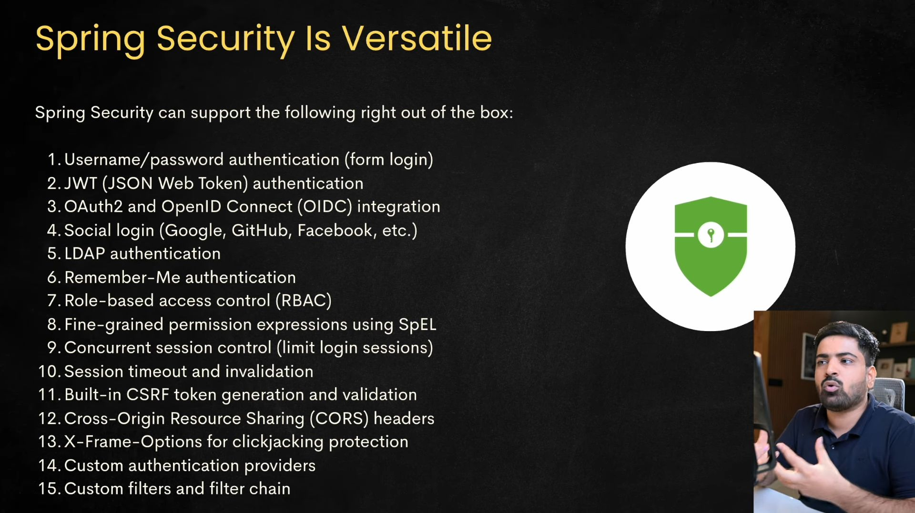
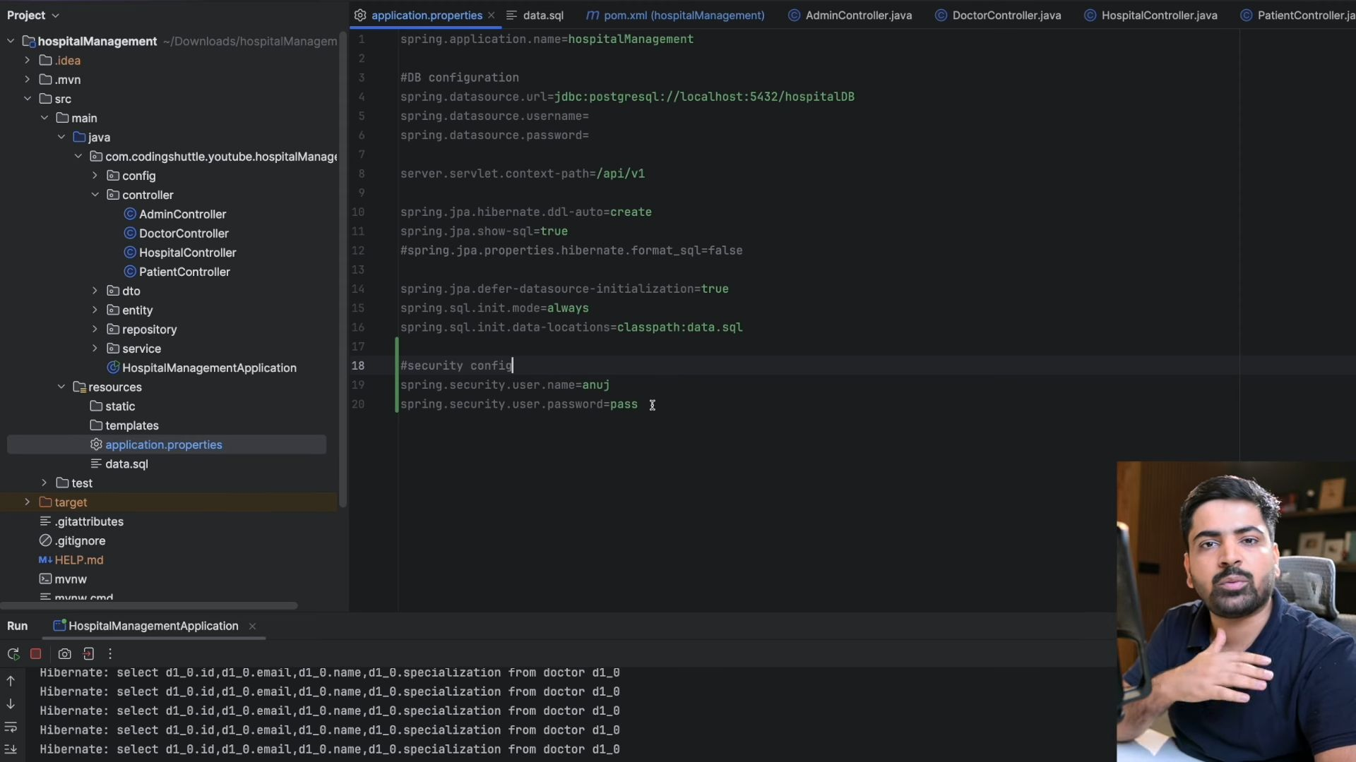
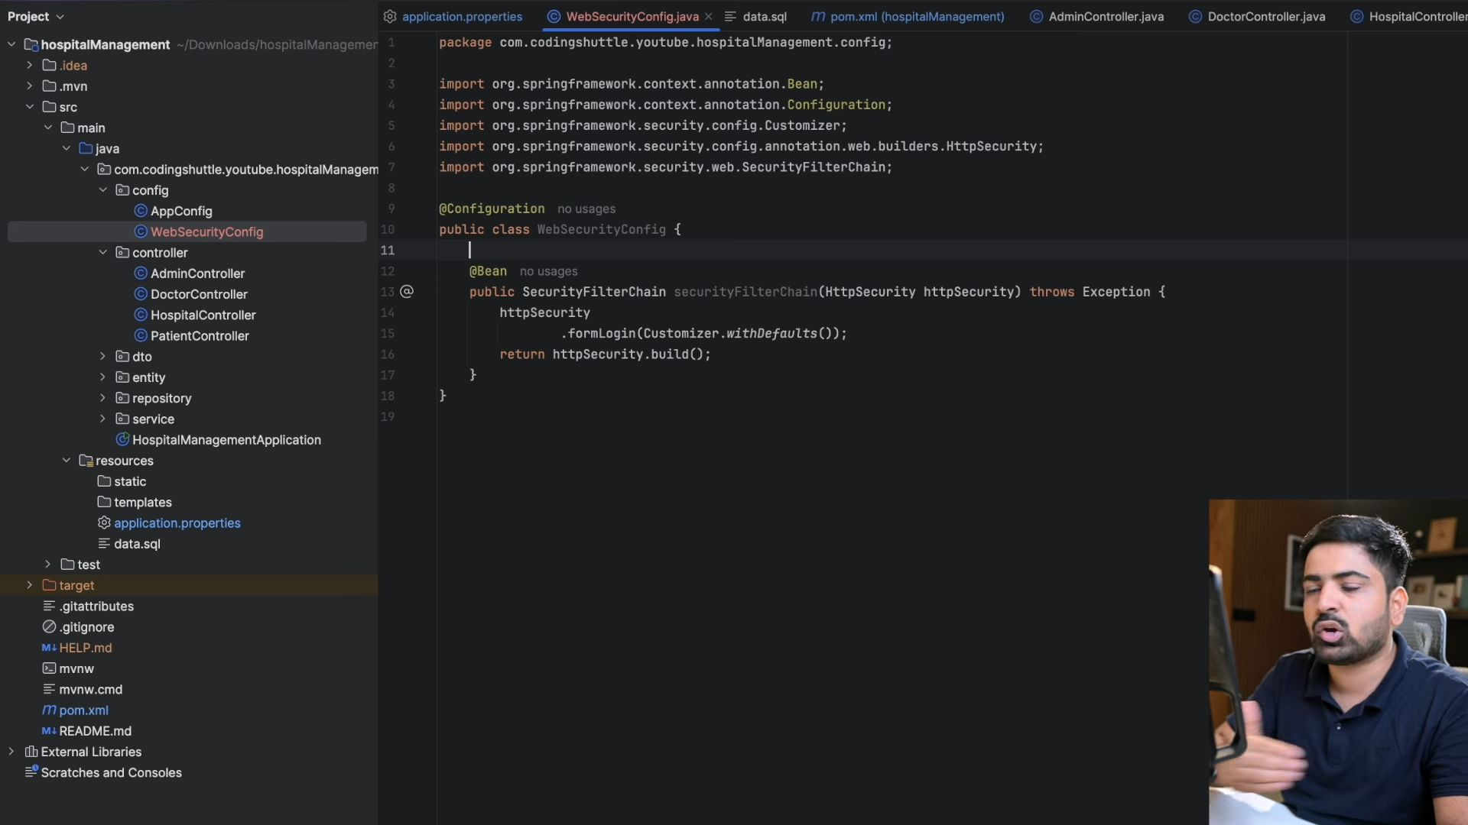
Jsb ye build run hoga toh ye jo humne apnu custom filter lagaya hai, ye wala change bhi show hoga.
By default the security filter chain saari request ko authenticated bana deti hai, which means har ek request phele login hogi, then he aap usme ja skte ho.
Iss above code mai humne abhi koi authorization measure toh bataya hai nhi, so isilye by default saari ki saari request public ho jayegi.
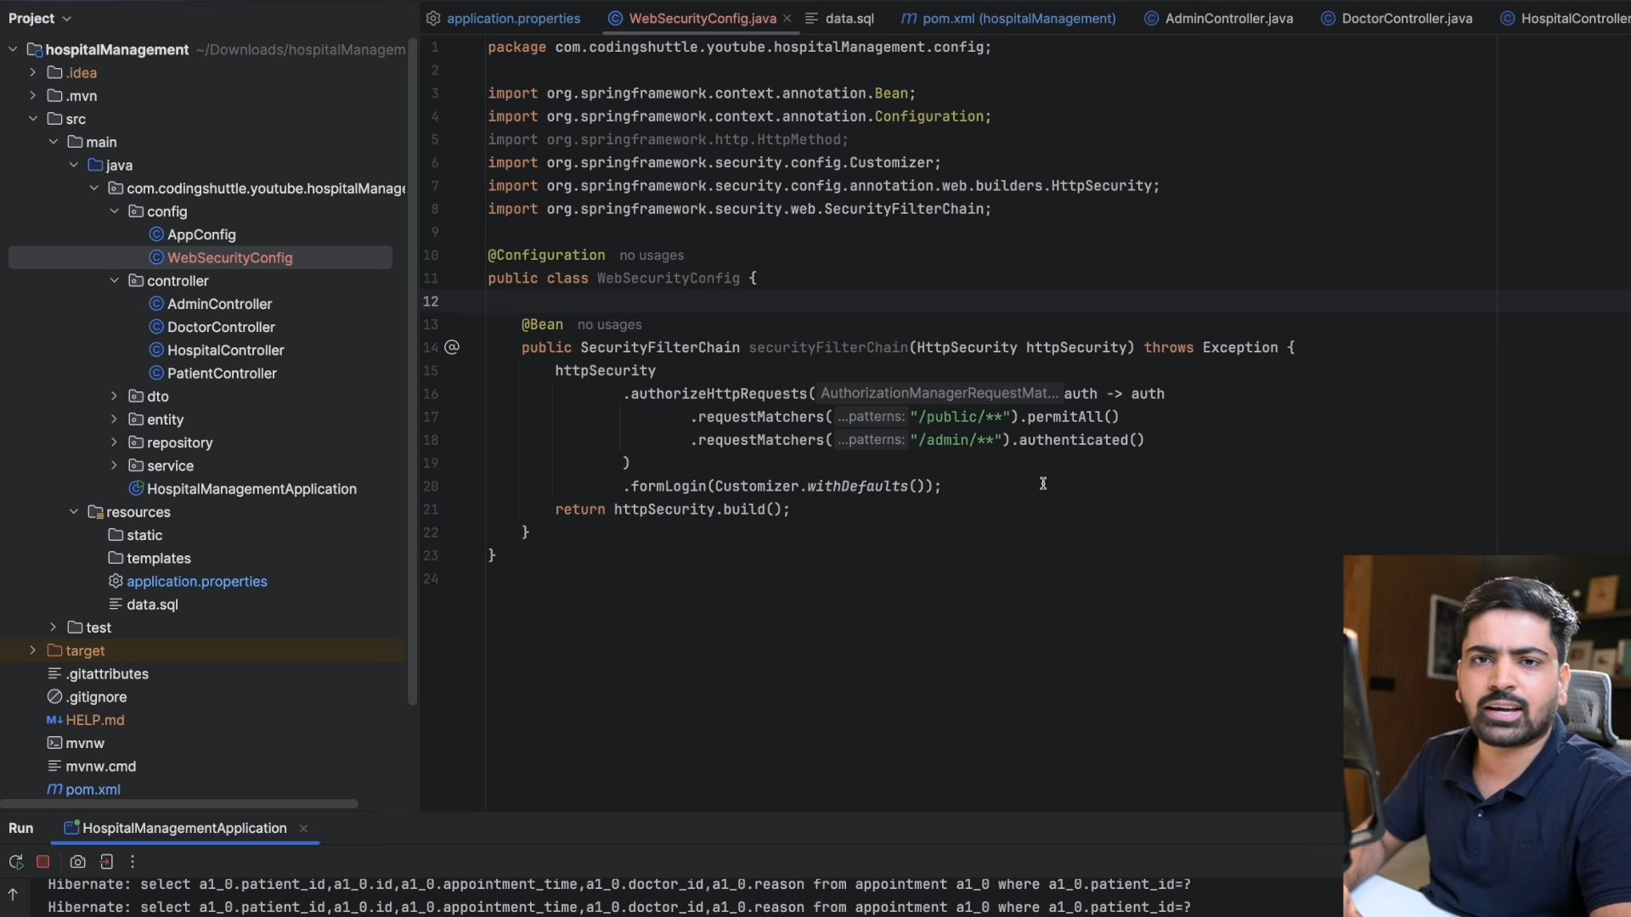Yaha pe humne request matchers lagya hai ki like /public se suru hone wali saari request ko permit kr do, meaning koi login ki jarurat nhi hai.
but /admin wali request k liye login krna padega tabhi access hoga.
One thing to notice here is that yaha pe hum bs admin wali request ko authenticated kr rhe hai but we are not checking whether this is a USER, ADMIN, or DOCTOR.
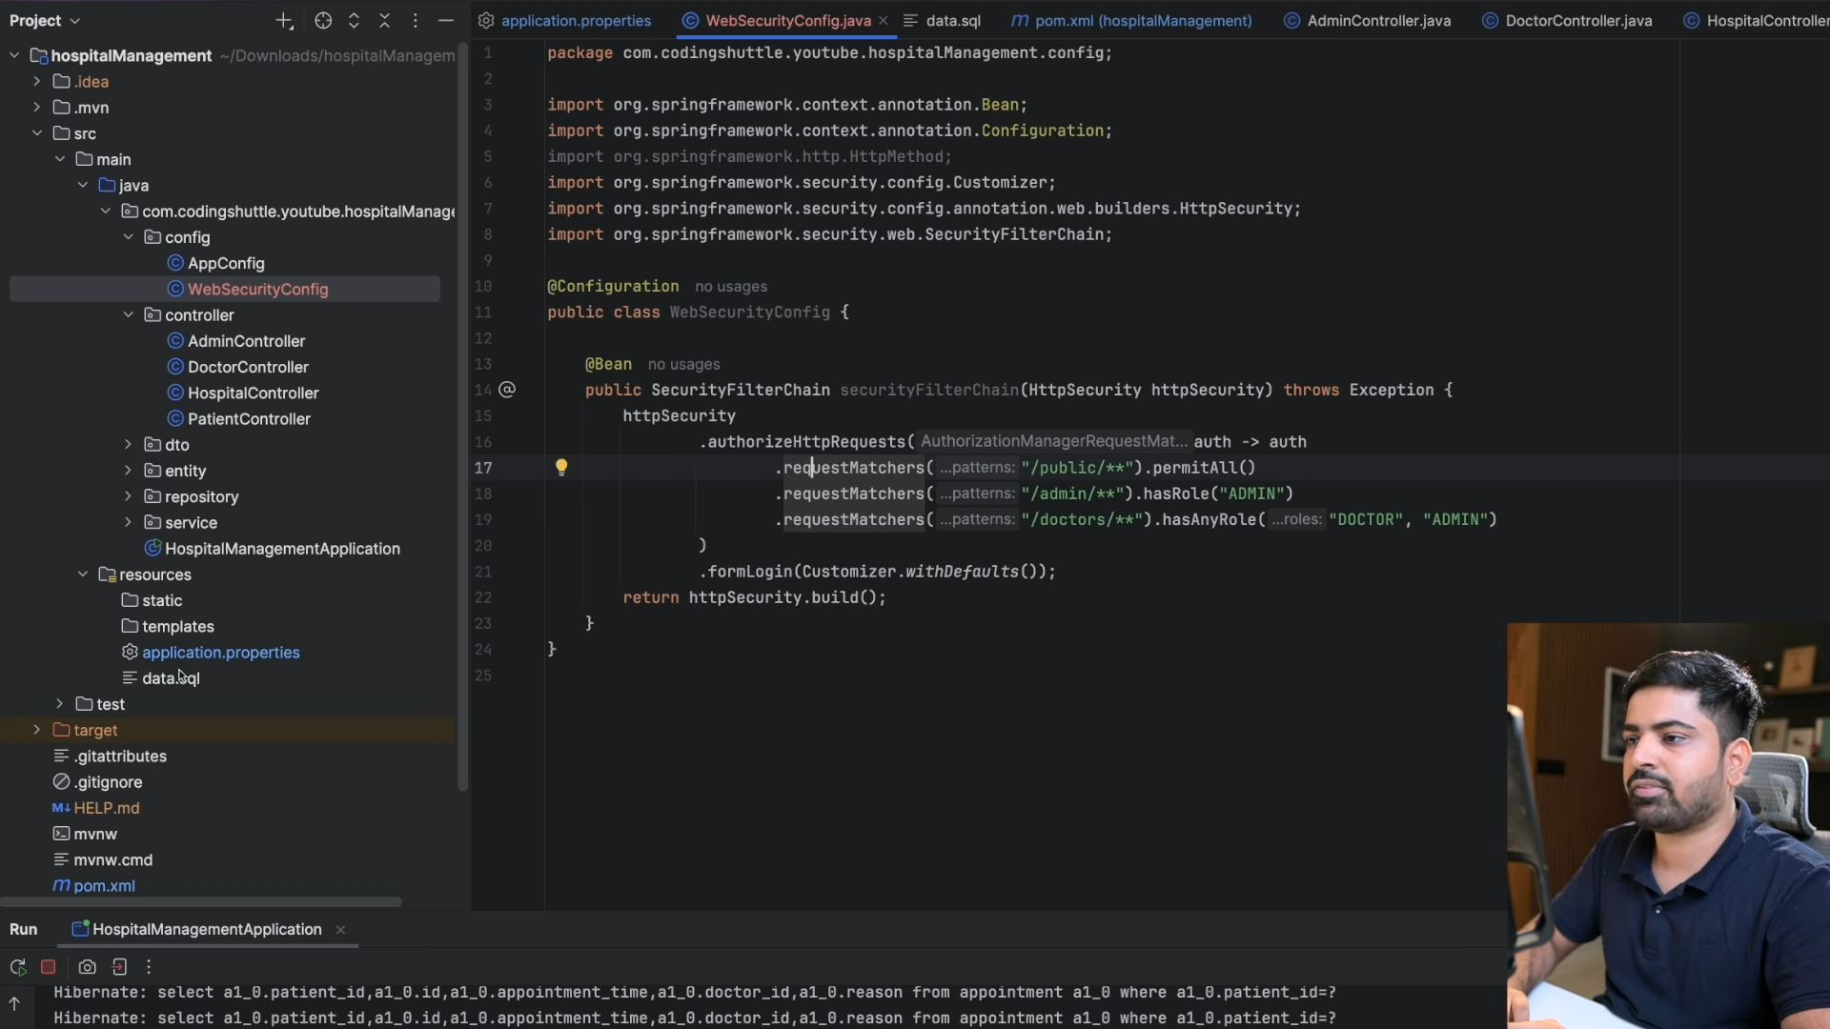Hum roles ko define kr skte hai application.properties mai jake like spring.security.roles= and then usko roles ka ek array de dia.
In Spring Boot, roles are not directly defined inside application.properties, but you can store role names or a list of roles as configuration values there.
Then you read them in your code (for example in a @Configuration class, @Service, or during user setup).

📝 Step 1 — Define Roles in application.properties

application.properties
app.security.roles=ADMIN,USER,MANAGER
Here, app.security.roles is a custom property key and the value is a comma-separated list of roles.

⚙️ Step 2 — Create a Configuration Class to Read These Roles
import org.springframework.boot.context.properties.ConfigurationProperties;
import org.springframework.stereotype.Component;
import java.util.List;
@Component
@ConfigurationProperties(prefix = "app.security")
public class SecurityRolesProperties {
private List<String> roles;
public List<String> getRoles() { return roles; } public void setRoles(List<String> roles) { this.roles = roles; }
}
This will automatically map the property app.security.roles to the roles list.

💡 Step 3 — Use These Roles in Your Security Config
import org.springframework.context.annotation.Bean;
import org.springframework.context.annotation.Configuration;
import org.springframework.security.config.annotation.web.builders.HttpSecurity;
import org.springframework.security.web.SecurityFilterChain;
@Configuration
public class SecurityConfig {
private final SecurityRolesProperties securityRolesProperties; public SecurityConfig(SecurityRolesProperties securityRolesProperties) { this.securityRolesProperties = securityRolesProperties; } @Bean public SecurityFilterChain securityFilterChain(HttpSecurity http) throws Exception { http .authorizeHttpRequests(auth -> auth .requestMatchers("/admin/**").hasRole("ADMIN") .requestMatchers("/user/**").hasAnyRole("USER","ADMIN") .anyRequest().authenticated() ) .formLogin(withDefaults()); System.out.println("Available roles: " + securityRolesProperties.getRoles()); return http.build(); }
}
Now you can control which roles exist by changing them in application.properties, and use them in your security configuration or for seeding default users.

✅ Summary
- You don’t assign roles to users in application.properties.
- You can store the list of allowed roles there and use them in code.
- Actual user-role assignments are typically stored in a database.
But I will create my in-memory user details manager.
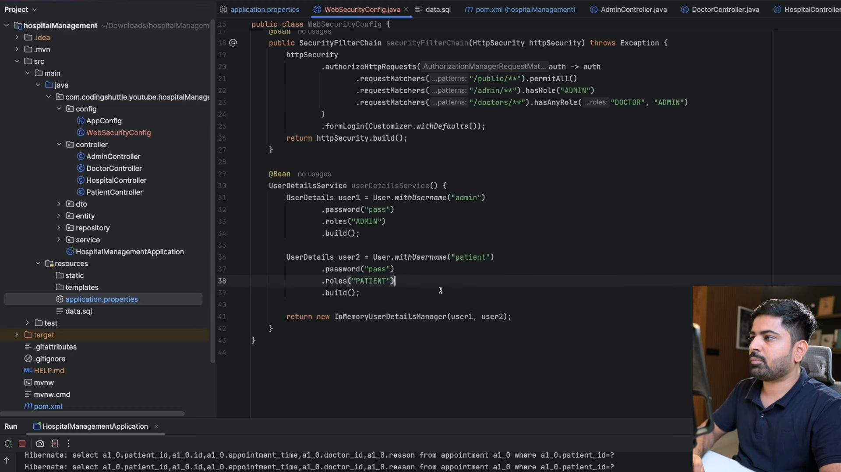
Ye phele jo user tha wo toh humne comment kr dia tha.
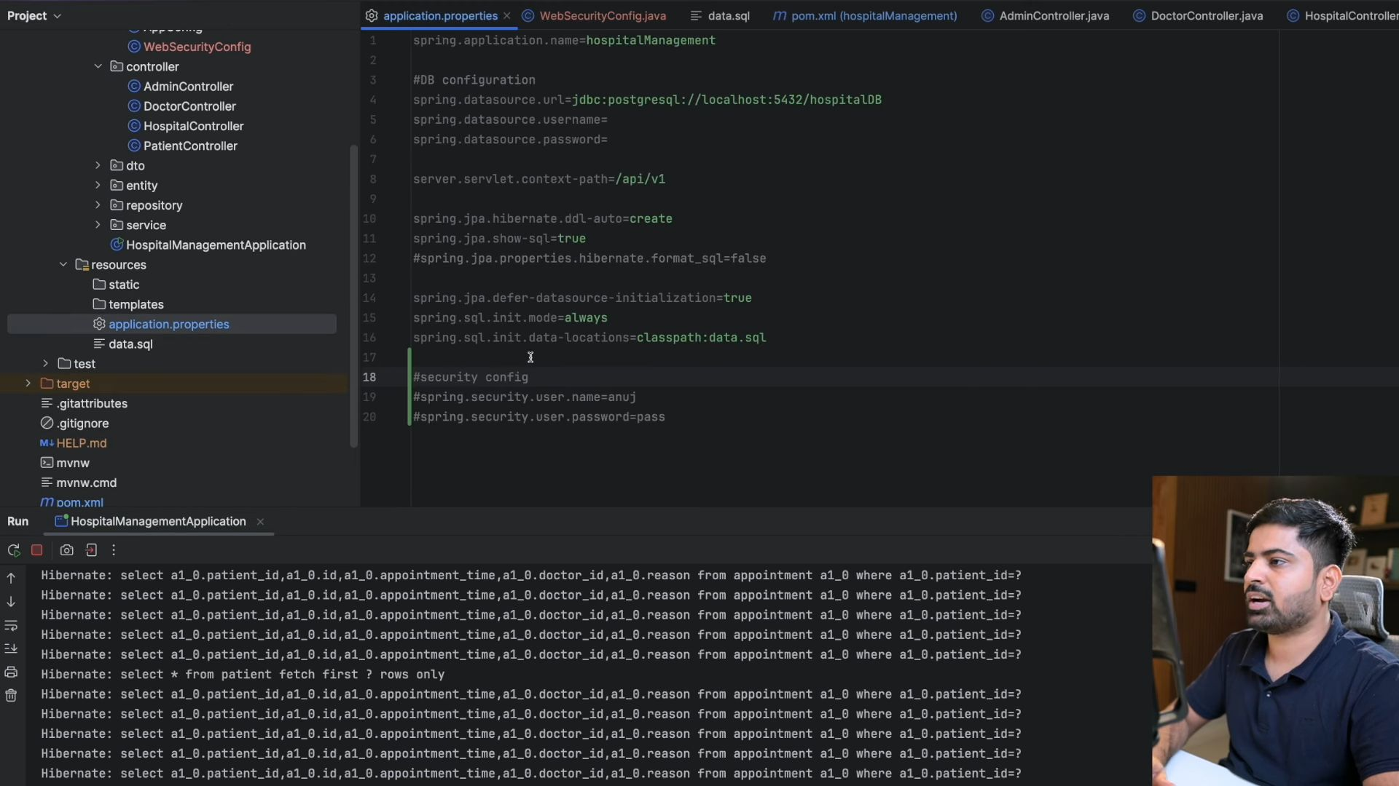
But we cannot directly give the password, so we will use passwordEncoder.
